**Exercise 3. Time-varying productivity (Arctic Sardine MU1)**

|  |
| --- |
| **Exercise Goal:** Identify ways to define an LRP for Arctic Sardine MU1 in a data-rich context with time varying productivity. |

|  |
| --- |
| **Exercise Activity:**   1. How are weight-at-age and maturity-at-age changing over time? 2. What parameter(s) would you use to represent how productivity is changing over time? 3. How would you describe the change in productivity over time? 4. Evaluate at least 2 approaches (one based on *SSB* and one based on *F*) to defining an LRP for Arctic Sardine MU1 and identify the preferred approach. 5. As a group, complete the slides in the Powerpoint File. The last slide will be presented by a group member at the beginning of the workshop tomorrow. Explain:    1. **Candidate approaches** (indicators and LRPs) considered, and their pros and cons    2. The **preferred approach and rationale** (indicator and LRP)       1. Does the choice reflect any candidate **best practice** criteria?       2. Any underlying **assumptions** of the preferred approach?    3. Include a **time series plot** of the indicator and add a line to represent the LRP.    4. Recommend the current (Year 50) **status** for the stock (above or below the LRP). Is the **status** different in Year 20? |

**Background:**

An age structured model has been fit for Arctic Sardine in MU1. This is the same type of model that was used for Exercise 2. For this exercise, consider that there is non-stationary in weight-at-age.

**Dataset:**

* Annual weight-at-age (g), maturity-at-age (proportion mature), and vulnerability-at-age (proportion selected to the fishery) over the historical time period
* Model-estimated spawning stock biomass (*SSB* in kt), recruitment at age 0 (*Rec* in billions), total biomass (*B* in kt), catch (kt), fishing mortality rate (*F*), empirical acoustic index of SSB (kt) for years 26-50
* Unfished spawning biomass per recruit (phi0) calculated using annual weight-at-age and maturity-at-age
* A dynamic unfished spawning stock biomass (dynamic SSB0) has been provided for the historical time series. This is generated by projecting SSB from the beginning of the time series to the terminal year of the reconstruction in Year 50 with *F*=0 using the recruitment deviations from the model fit with the historical catch. A dynamic *SSB0* was estimated two different ways:

|  |  |  |  |
| --- | --- | --- | --- |
| **Type** | **Parameter in Dataset** | **recruitment deviations** | **weight-at-age** |
| Full | dynamicSSB0a | annual | annual |
| Partial | dynamicSSB0g | annual | mean over first 5 years |

The full dynamic *SSB0* assumes that the changes in productivity are independent of *F* and not density dependent. The partial dynamic *SSB0* assumes that the changes in growth observed over time would not have occurred in the absence of fishing.

**Some options:** (some calculations have been started in the R script)

* Empirical biomass indicator (acoustic index of SSB) and LRP
* Empirical *F* indicator (relative exploitation rate = catch/acoustic index of SSB) and LRP
* Model-based biomass indicator (e.g., SSB) and theoretical (e.g., *SSB0*, *SSBMSY*) LRP
  + Static – e.g., based on equilibrium assumptions using weight-, maturity-, and vulnerability-at-age data over a specific time period
  + Dynamic – e.g., using various assumptions for how changes in weight-at-age and maturity-at-age over time are considered
* Model-based *F* indicator (e.g., *FMSY*) LRP
  + Static – e.g., based on equilibrium assumptions using weight-, maturity-, and vulnerability-at-age data over a specific time period
  + Dynamic – e.g., using various assumptions for how changes in weight-at-age and maturity-at-age over time are considered
* Model-based biomass indicator (e.g., SSB) and LRP based on stock recruitment relationship or historical SSB

**Candidate Criteria for Best-Practice Indicators and LRPs:**

* Consistent with an objective to avoid serious harm to the stock
* Based on the best available information
* Operationally useful
* Reliably estimated

**Table 1. Data Files for Exercise 3**

|  |  |  |
| --- | --- | --- |
| File Type | File Name | Description |
| Microsoft PowerPoint 2016 - Review 2016 - PCMag UK | BO Group Ex3.pptx | Powerpoint for group exercise and presentation |
| C:\Users\barretttj\AppData\Local\Microsoft\Windows\INetCache\Content.MSO\3B9046F.tmp | ex3.R | R script that imports data with plots and calculations started. Use the main LRP folder as your working directory. |
| These files are used in ex3.R but do not need to be opened: | | |
| R (programming language) - Wikipedia | ex3_data.rda | R data object: a list with elements:  WAA = data frame (weight-at-age by year)  MAT = data frame (maturity-at-age by year)  VUL = data frame (vulnerability-at-age by year)  D = data frame (SSB, recruitment, total biomass, catch, F, acoustic index, unfished spawning biomass, steepness, dynamic SSB0 estimates, by year) |
| C:\Users\barretttj\AppData\Local\Microsoft\Windows\INetCache\Content.MSO\3B9046F.tmp | functions.R | R script with functions (in main LRP directory) |

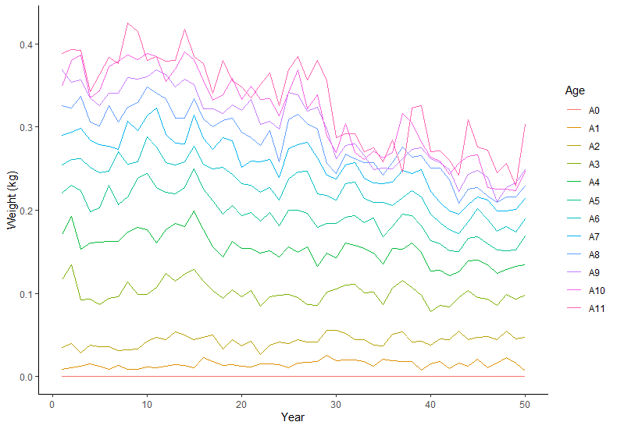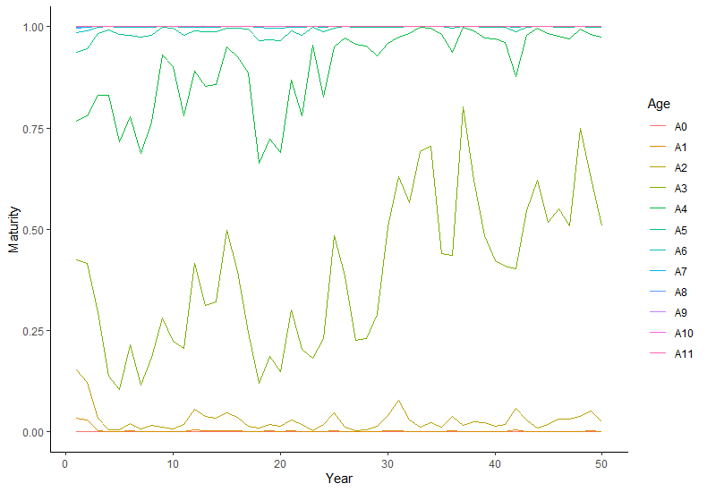 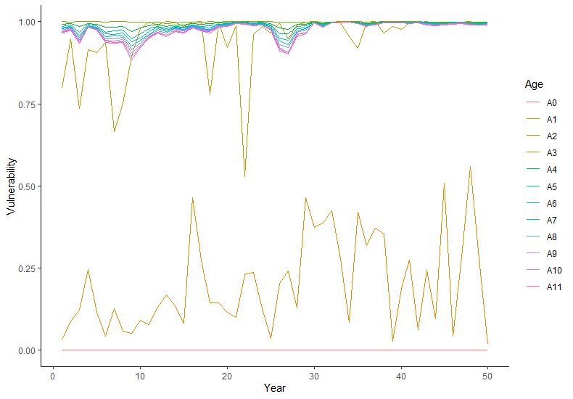

**Figure 1. Time Series Plots on Weight-at-age, Maturity-at-age, and Vulnerability-at-age**

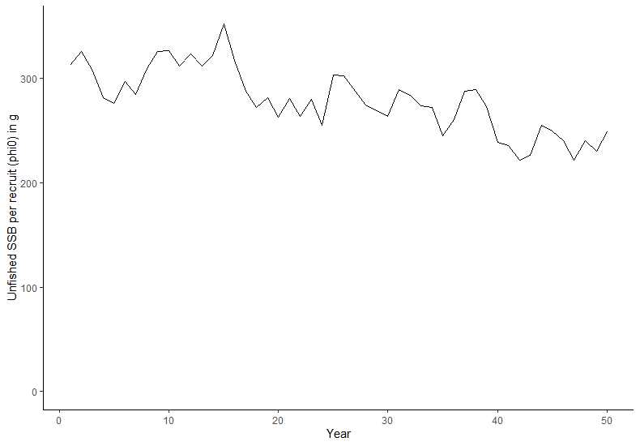

**Figure 2. Time Series Plot of Annual phi0 (Unfished SSB per Recruit)**

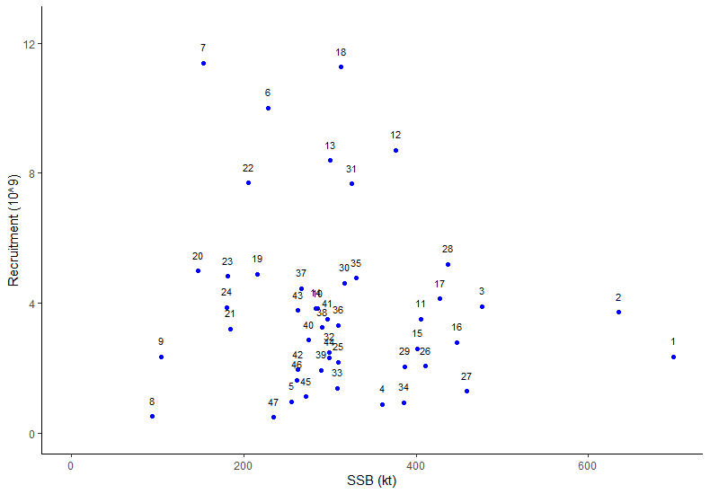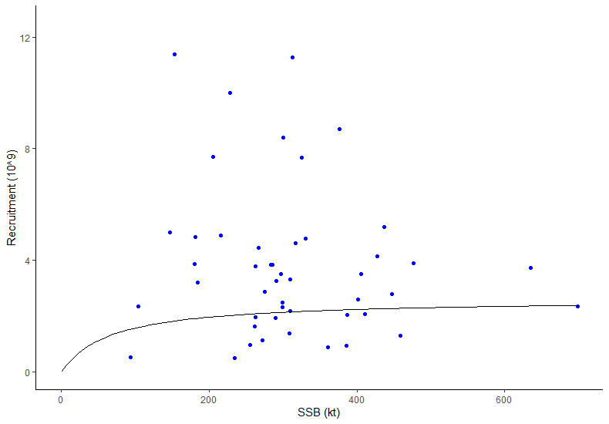

**Figure 3. Estimated Stock Recruitment Pairs (left panel: data labels are years; right panel: Model Estimated Fit)**

*Note: Model estimated Beverton-Holt stock recruitment relationship, a =* *0.03988293; b = 0.01525998, estimated from assumed h = 0.75 and mean phi0 over the first 5 historical years*

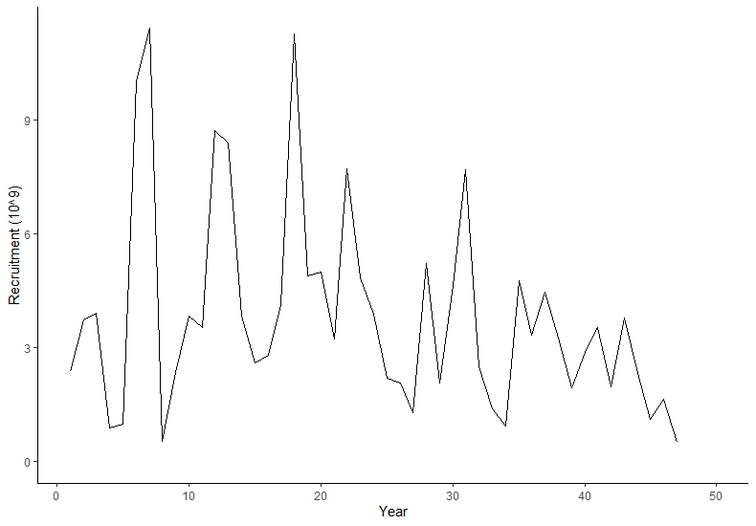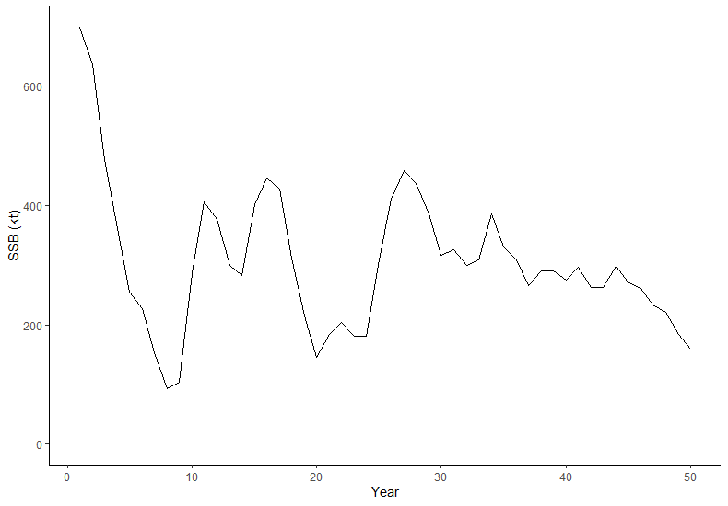

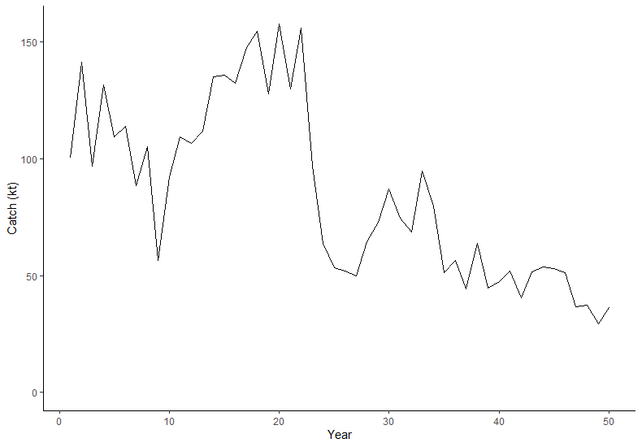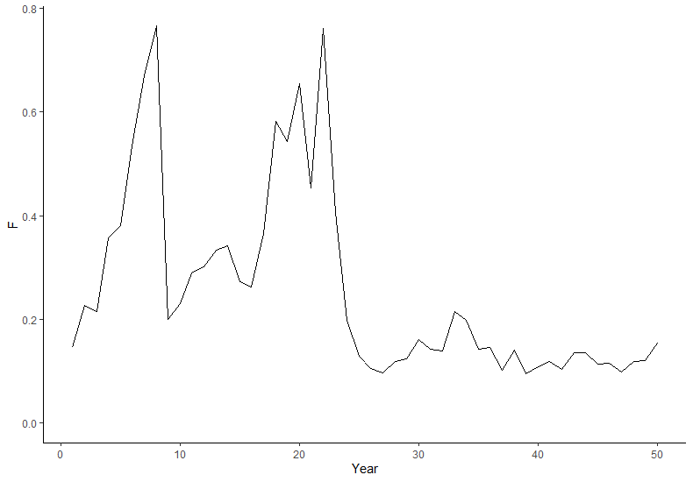

**Figure 4. Time Series Plots for Model Estimated Recruitment, Model Estimated Spawning Stock Biomass, Total Catch, and Model Estimated *F* (maximum *F*-at-age)**

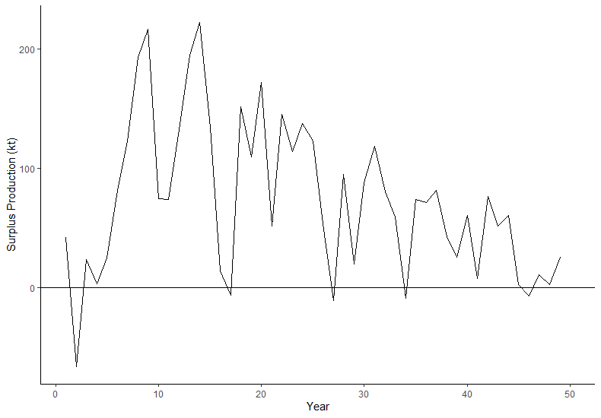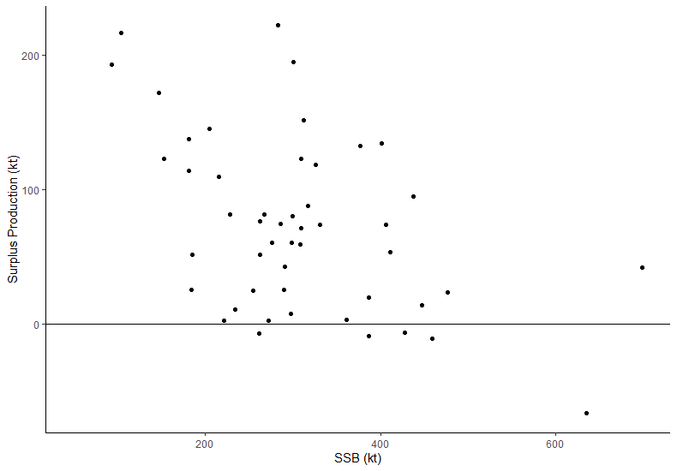

**Figure 5. Time Series Plot for Surplus Production and Plot of Surplus Production vs. Model Estimated Spawning Stock Biomass**

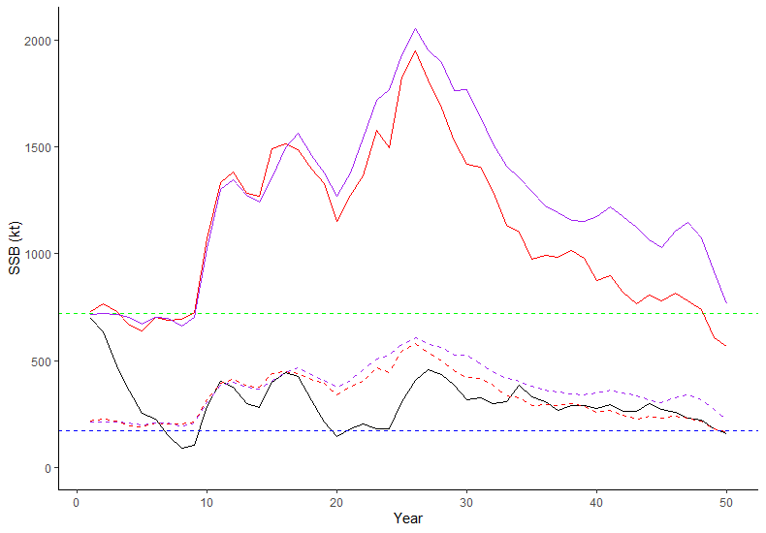

**Figure 6. Time Series Plot for SSB with Some Candidate SSB Metrics to use for LRP indicators**

*Black line = annual SSB; green line = equilbiurm SSB0 based on phi0 (unfished SSB per recruit) from first 5 historical years, blue line = equiliburm SSBMSY estimated using data over last 10 years, red lines = dynamic SSB0 (solid) and dynamic SSBMSY (dashed) based on full dynamic assumptions, purple lines = dynamic SSB0 (solid) and dynamic SSBMSY (dashed) assuming mean growth first 5 historical years*

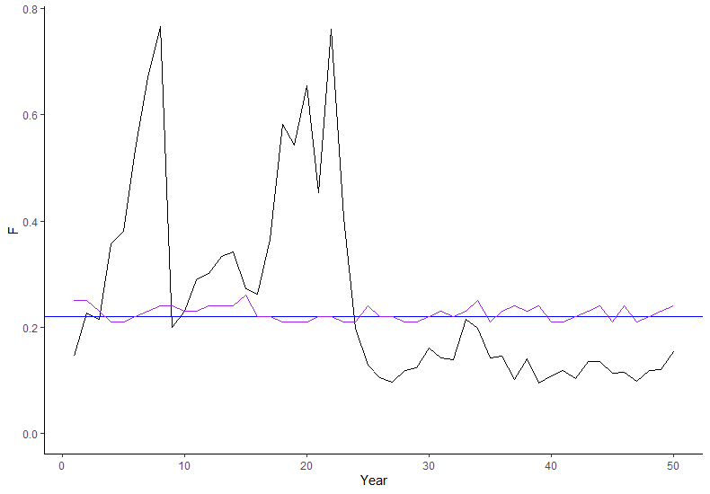

**Figure 7. Time Series Plot for Historical *F* with Some Candidate *F* Metrics to use for LRP indicators**

*Black line = annual F; blue line = equiliburm FMSY estiamted using mean growth, maturity, and selectivity over last 10 years, purple line = equilibrium FMSY assuming annual growth, maturity, and selectivity*

**Empirical Indicators:**

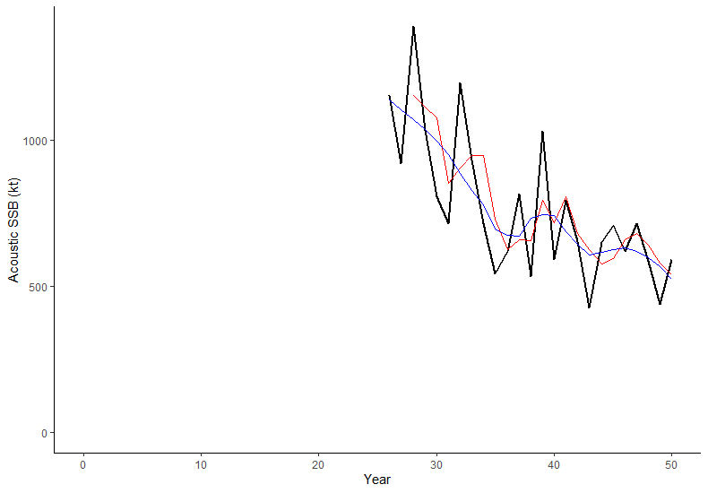

**Figure 8. Acoustic Index of SSB for MU1 (years 26-50)**

*Notes: Index is a relative index of SSB*

*Black line = Annual index, Red line = 3 year moving average, Blue line = loess smoother with span = 0.5*

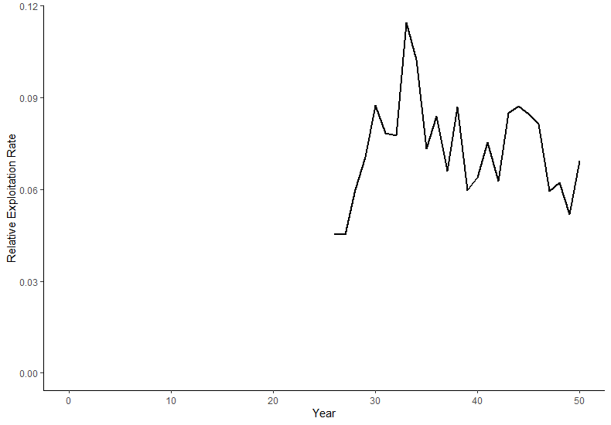

**Figure 9. Relative Exploitation Rate (years 26-50)**

*Notes: Calcualted as the ratio of Catch to the loess smoothed acoustic index of SSB*